Chain Operated Roman Blind Fitting Instructions
Your made to measure Roman blind is supplied complete and ready to hang on the brackets supplied. Please read the following instructions carefully before fitting your blind.
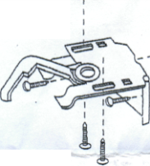
Fixings
The brackets are designed to be used as either top fix (top of the /window recess or ceiling) or face fixed (wall or window frame). In order to provide the stability for fixing or removing the rail it is essential that the brackets are fixed securely.

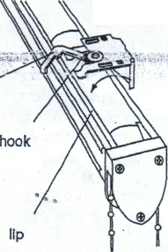
Attaching Brackets
Please note when attaching brackets to their fixings allow a minimum of 2cm from the ends of the headrail to avoid obstructing the end mechanism. For larger blinds extra bracket(s) will be supplied and should be fitted evenly between the end brackets

To attach blind to the brackets you have just fitted simply raise the headrail into position as illustrated. When fitting the headrail ensure that the two hooks on the brackets are hooked underneath the lip in the headrail.
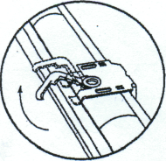

Securing headrail to bracket
Press the headrail in place with a slight upwards pressure, then push the swivel clamp to the left which will lock the headrail correctly in place. The fabric on our chain operated Roman blind system can be attached and detached to the headrail for perfect alignment

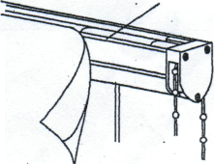
Using the control chain to operate the blind
Pulling gently on the chain in one direction will lower the blind and in the other it will raise. It is possible on certain blind mechanisms you can lower the blind and by continuing to pull the chain in the same direction the blind will raise again – you may notice that the blind will pull up unevenly if you do this, so you should reverse the direction you are pulling the chain in, until the blind lowers and then raises again, this time evenly.

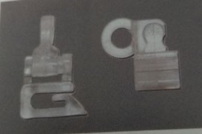
Safety Features
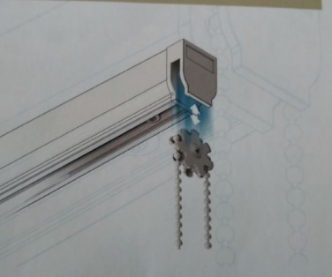
The Blind has several `Child Safety` feature designed to fail under particular criteria, preventing accidents and protecting the blind. Should these fail as designed under certain load conditions, they can easily be put back into place. The blind should contain a spring toggle which may come off and Blind Clips which will part, but clip easily back together.

Drive Wheel
The blind headrail will also contain a removable drive wheel, which will fail under load criteria, but can be placed back into place easily as shown.

