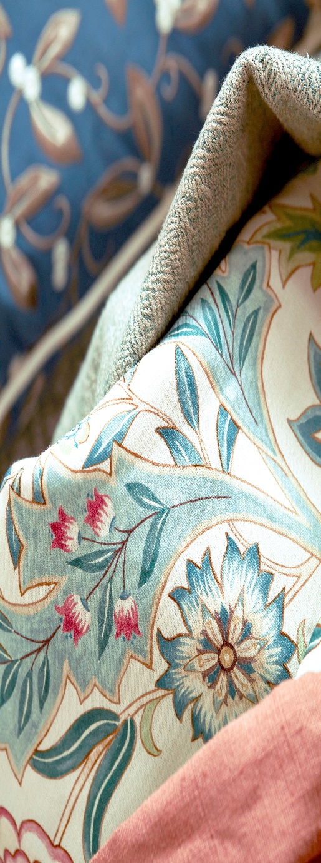
Express Curtains Sample Order Form

If you would like to order any fabric samples from ourselves, please complete the form below and send payment (via Paypal only for Samples please).

Charges are £1.50 per three samples ordered (e.g. for 1–3 samples the charge is £1.50, for 4–6 samples the charge is £3.00, for 7–9 samples the charge is £4.50 and so on).

Order form for samples:

Name

Email Address

Telephone Number

Sample Delivery Address

Samples Required (Please detail brand, design name, colour name and code if applicable)

